Date of publication MMM-22, yyyy, date of current version MMM-dd, yyyy.
www.computingonline.net / computing@computingonline.net
Print ISSN 1727-6209
Online ISSN 2312-5381
DOI 10.47839/ijc.19.3.XX
Designing Microcontroller
module with target to use
AVR/PIC assembler
Veselin Stanchev , Eng. MSc¹

¹Department ICT, Technical University-Plovdiv Branch, Plovdiv, Bulgaria
Corresponding author: Veselin Stanchev , Eng. Msc (e-mail: vrstanchev@tu-plovdiv.bg).

ABSTRACT Assembly languages are very useful for programming of micro-controllers, microprocessors, embedded devices, real-time operating systems. The most natural way for micro-controller programming is to use Assembly languages. For different types of micro-controller families - AVR/PIC-based, there are different assembly languages. For AVR-based micro-controllers such as - ATtiny13,ATtiny85,ATMega32u4 different assembly languages can be used – AVR Assembler or GNU Assembler. Micro-controllers can be used for micro-controller modules design. This paper describes design and programming of micro-controller module which uses both AVR-based and PIC-based micro-controller. This module can be used for educational purposes. It shows communication between its micro-controllers.

KEYWORDS PCB; MCU; AVR/PIC; Assembly language; Micro-controller module

INTRODUCTION Usage of free assembly languages is very important for understanding Computer Architectures. Free assembly languages can be used for university purposes. To explain usage of them for micro-controllers, micro-controller boards can be designed using open-source EDA software such as: Fritzing or LibrePCB. On single micro-controller board can be used micro-controllers together.
They are several variants for that – usage of PIC-based micro-controllers, usage of AVR-based micro-controllers or AVR/PIC micro-controllers together. Target of the current project is to use AVR assembler and PIC assembler through custom communication protocol. There are requirements for hardware and software part of the project. ATtiny85 and PIC10F320 are chosen. For software part of the project are used tools such as: Git, GNU Make, GNU GCC, GNU PIC Utils, avra. Hardware part is created by using of LibrePCB.
LibrePCB is used for schematic design, footprints of micro-controllers and layout of the micro-controller module.
MATERIAL AND METHODS Project orientation is fully practical. The micro-controller module can be used for university purposes. For realization of the project are used open-source tools. Because of that project can be upgraded easily. The project can be used for: assembly language labs, micro-controller labs, understanding of micro-controller communication, understanding of AVR/PIC programming.
- Existing micro-controller modules ANAVI MACRO PAD 2, ANAVI LIGHT CONTROLLER, Raspberry Pi Pico and AVR64DD32 Curiosity Nano. For each of them are analyzed: supported micro-controllers, supported communication protocols, supported interfaces, supported assembly languages.
Example: ANAVI MACRO PAD 2 and ANAVI LIGHT CONTROLLER.
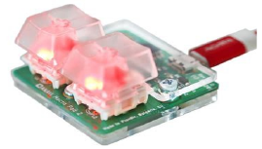
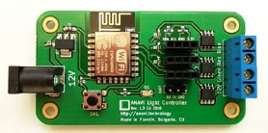

Figure 1. ANAVI MACRO PAD 2 Figure 2. ANAVI LIGHT CONTROLLER
- Requirements of the project are software-based and hardware-based. For hardware-based requirements: AVR/PIC-based micro-controllers has to be chosen. ATtiny85 and PIC10F320 are chosen.
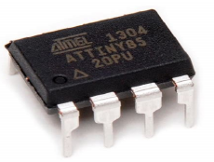
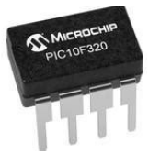

Figure 3. ATTiny85 Figure 4. PIC10F320
For design of micro-controller module LibrePCB is chosen. AVR/PIC-based micro-controller’s symbols are created. Footprints for them are created.
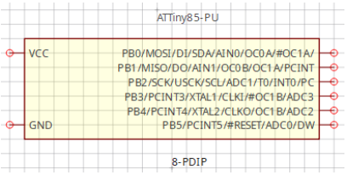
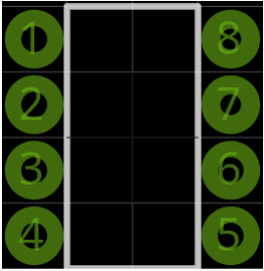

Figure 5. Symbol of ATTiny85 Figure 6. Footprint of ATTiny85
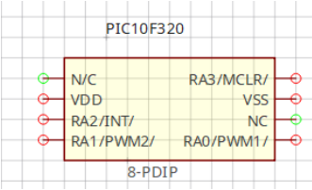
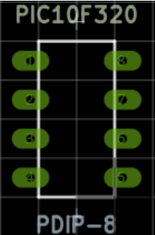

Figure 7. Symbol of PIC10F320 Figure 8. Footprint of PIC10F320

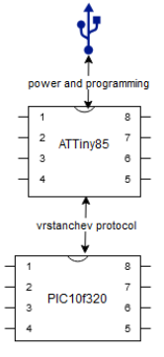

USB interface is chosen for power and programming. So micro-controller module block diagram is created.

Figure 9. Micro-controller module block diagram

Bev

I. ARTICLE FORMATING
A. TITLE
PAPER has to be informative within a reasonable number of words, but it may not include more than 90 characters. Please avoid abbreviations and formulae where possible.
B. AUTHOR NAMES AND AFFILIATIONS
Where the family name may be ambiguous (e.g., a double name), please indicate this clearly. Present the authors' affiliation addresses (where the actual work was done) below the names. Indicate all affiliations with a lower-case superscript letter immediately after the author's name and in front of the appropriate address. Provide the full postal address of each affiliation, including the country name and, if available, the e-mail address of each author. Please mark a corresponding author.
C. ABSTRACT
A concise and factual abstract is required. The abstract should state briefly the purpose of the research, the principal results and major conclusions. An abstract is often presented separately from the article, so it must be able to stand alone. For this reason, References should be avoided, but if essential, then cite the author(s) and year(s). Also, non-standard or uncommon abbreviations should be avoided, but if essential they must be defined at their first mention in the abstract itself. The abstract must summarize the paper content and should have a reasonable number of words – 150-175 is an optimum number.
D. KEYWORDS
Immediately after the abstract, provide a maximum of 10 keywords, using American spelling and avoiding general and plural terms and multiple concepts (avoid, for example, 'and', 'of'). Be sparing with abbreviations: only abbreviations firmly established in the field may be eligible. These keywords will be used for indexing purposes.
D. INTRODUCTION
There needs to be an adequate summary of references to describe the current state-of-the-art or a summary of the results.
E. MATERIAL AND METHODS
Provide sufficient detail to allow the work to be reproduced. Methods already published should be indicated by a reference: only relevant modifications should be described.
F. RESULTS
Results should be clear and concise.
G. CONCLUSIONS
The main conclusions of the study may be presented in a short Conclusions section, which may stand alone or form a subsection of a Discussion or Results and Discussion section.
H. ACKNOWLEDGEMENTS
Collate acknowledgements in a separate section at the end of the article before the references and do not, therefore, include them on the title page, as a footnote to the title or otherwise. List here those individuals who provided help during the research (e.g., providing language help, writing assistance or proofreading the article, etc.).
I. SUBDIVISION
Divide your paper into clearly defined and numbered sections. Subsections should be numbered as A, B, C, …, etc. (the abstract is not included in section numbering). Use this numbering also for internal cross-referencing: do not just refer to 'the text'. Any subsection may be given a brief heading. Each heading should appear on its own separate line.
J. FORMULAE
Mathematical expressions and Greek or other symbols must be written clearly with ample spacing.
K. UNITS
Follow internationally accepted rules and conventions: use the international system of units (SI). If other units are mentioned, please give their equivalent in SI.
L. FOOTNOTES
Footnotes should be used sparingly. Number them consecutively throughout the article, using superscript Arabic numbers. Many word processors build footnotes into the text, and this feature may be used. Should this not be the case, indicate the position of footnotes in the text and present the footnotes themselves separately at the end of the article. Do not include footnotes in the Reference list.
M. REFERENCES
References must appear as a separate bibliography at the end of the paper, numbered by numerals in square brackets.
References to papers published in languages other than English must be translated into English indicating the original language given in brackets in the end of the reference e.g. (in German).
References in the text are indicated in square brackets. Journal titles must not be abbreviated. Please give journal volumes, issues (numbers) and page numbers.
N. FIGURES
Electronic version in EPS (Encapsulated Postscript) is preferred. The illustrations must be sharp, noise free and of good contrast.
O. PLEASE DO NOT:
- Supply files that are optimised for screen use (e.g., GIF, BMP, PICT, WPG); the resolution is too low;
- Supply files that are too low in resolution;
- Submit graphics that are disproportionately large for the content.
II. PAPER SIZE
The authors should submit camera-ready paper in MS Word format by e-mail. Use A4 (210 x 297 mm) format of the paper. Leave 22,9 mm at the top, 18, 3 mm at the bottom, and 13,1 mm margins at left and right. The camera-ready paper size should be no more than eight pages without authors photos and CVs. Authors are strongly recommended to leave on the last page some place for photos and short author’s CVs. Please, don’t use numbering pages in your papers.
III. LAYOUT
The text should be typed single-spaced. Use Times New Roman typeface for normal text.
Center the title (Helvetica, 22 points, bold), author(s) name(s) (Helvetica, 10 points, bold), affiliation(s), address(es), e-mail and Web/URL (Times New Roman, 7 points, regular). Leave one blank line below the title, and affiliation(s).
Then put short abstract of the paper (no longer than 150 words). For word Abstract use Bold. After it insert one blank line.
Below insert a list (preceded with one and followed with two blank lines) of up to 10 keywords. For the word Keywords use Bold.
Type the text of the paper (10 points, regular) in two columns 8,5 mm wide, separated with a 5 mm space. Balance the length of the columns, especially on the last page of the paper. Each column should be justified. The first line of each paragraph is to be indented 5 mm. Headings must be numbered. Please use Roman numbers only. Use only one level of headings (Helvetica, 10 points, bold) and precede each of them with one blank line. Use spacing of 12 points before headings.
Place a full list of references at the end of the paper. Please place the references according to their order of appearance in the text. Enclose the numbers in square brackets.
IV. EQUATIONS
Equations should be placed in separate lines and numbered. Please use separate table's cells to place an equation and its number. Do not use any equations inside of paragraph. The numbers should be within brackets and right aligned. Please set in Microsoft Equation following fonts: Regular – 12 pt, Large index – 7 pt, Small index – 5 pt, Large symbol – 18 pt, Small Symbol – 12 pt. Leave one blank line above and below each equation. For example, the line expression

, (1)

where  – coefficient, – argument, – bias.
V. FIGURES AND TABLES
The figures and tables must be numbered, have a self-contained caption. Figure captions should be below the figures; table captions should be above the tables. Also, avoid placing figures and tables before their first mention in the text.
The text of figure captions should be 10 points high and bold. Use spacing of 6 points before and after. Leave one line after the tables unless a section title follows. Table captions and figure captions should be centered. Large figures and tables may span both columns. Leave one blank line before the caption of the table. Do not indent the captions. Do not use characters smaller than 10 point in figures.
All the figures, graphs and photographs should be numbered and referred in the main text. Abscissas and ordinates of all graphs should be labeled with symbols and units as in Fig. 1.
Use the abbreviation “Fig.” even at the beginning of a sentence. The text in the figures may be Times New Roman.
Do not use abbreviations in the titles unless they are unavoidable.
All figures, graphs and photographs must be in black and white (or gray shades).
Font size in tables is 8 pt.
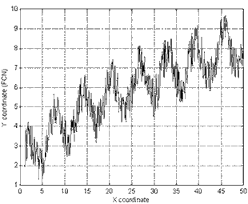
Figure 1. Example of a graph.

Table 1. Symbols
Document section | Font size and style
Φ | magnetic flux
B | magnetic flux density, magnetic induction
H | magnetic field strength
m | magnetic moment
M | magnetization
4πM | magnetization
σ | specific magnetization
j | magnetic dipole moment
J | magnetic polarization
μ | permeability
μ_{r} | relative permeability
w, W | energy density
N, D | demagnetizing factor
VI. CONCLUSIONS
We thank you in advance for supplying carefully prepared camera-ready papers, which can be sent for publication without modification.
VII. INDICATIONS FOR ‘REFERENCES’
References need not be cited in text. When they are, they appear on the line, in square brackets, inside the punctuation. Multiple references are each numbered with separate brackets. When citing a section in a book, please give the relevant page numbers. In text, refer simply to the reference number. Do not use “Ref.” or “reference” except at the beginning of a sentence: “Reference [3] shows ...”. Please do not use automatic endnotes in Word, rather, type the reference list at the end of the paper using the “References” style.
Reference numbers are set flush left and form a column of their own, hanging out beyond the body of the reference. The reference numbers are on the line, enclosed in square brackets. Do not combine references. There must be only one reference with each number. If there is a URL included with the print reference, it can be included at the end of the reference.
Please do not forget including the relevant DOIs for references where available. So, it some references has assigned DOI, you must put it.
Please visit this link at CrossRef for DOI finding https://apps.crossref.org/SimpleTextQuery. You should put your reference or all references list in text box and click “Submit”. DOIs will be displayed for appropriate references.
Text size in references is 8 pt.
References
Reference to a journal publication:
[1] J. van der Geer, J.A.J. Hanraads, R.A. Lupton, “The art of writing a scientific article,” Journal of Science Communication, vol. 16, issue 3, pp. 51-59, 2000.

Reference to a book or a report:
[2] W. Strunk Jr., E.B. White, The Elements of Style, third ed., Macmillan, New York, 1979, 350 p.

Reference to a chapter in an edited book:
[3] G.R. Mettam, L.B. Adams, How to prepare an electronic version of your article, in: B.S. Jones, R.Z. Smith (Eds.), Introduction to the Electronic Age, E-Publishing Inc., New York, 1999, pp. 281-304.

Reference to a conference proceedings:
[4] C.-H. Lin, J.-C. Liu and C.-W. Liao, “Energy analysis of multimedia video decoding on mobile handheld devices,” Proceedings of the International Conference on Multimedia and Ubiquitous Engineering, Seoul, Korea, April 26-28, 2007, pp. 120-125.

Online publication:
[5] M. Shell, The IEEEtran.cls Package, 2007, [Online]. Available at: http://www.ctan.org/tex-archive/macros/latex/contrib/IEEEtran/

 | FIRST A. AUTHOR Short CV of author (10-20 lines), including: education, current position and areas of scientific interests, scanned photo.

Second B. AUTHOR Short CV of author (10-20 lines), including: education, current position and areas of scientific interests, scanned photo.

